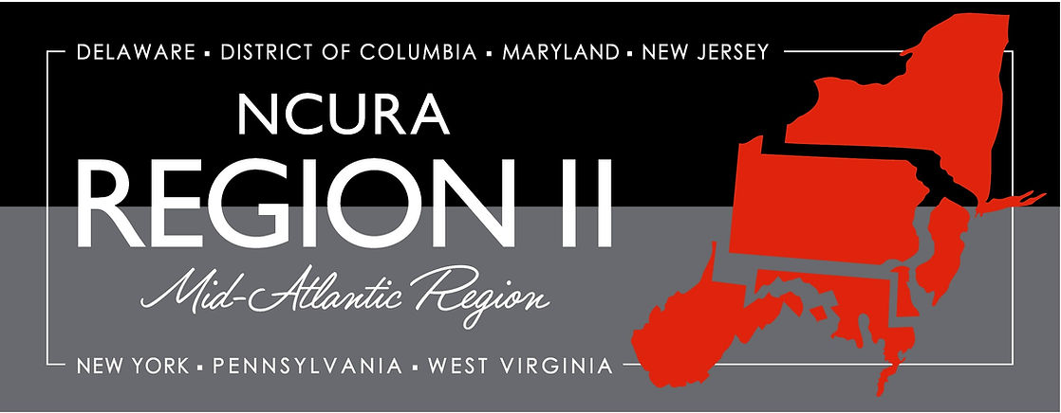

National Council of University Research Administrators Region II Cheryl-Lee Howard Mentor Me Program
2024 Mentee Application
Name:
Title:
Institution:
Address:

Phone: Email:

- Number of Years in Research Administration
2-3 years 4-5 years 6-10 years 10-20 years 20+ years

- Number of Years in Current Position
0-3 years 4-5 years 6-10 years 10-20 years 20+ years

- Work arrangements
In-Person Remote Hybrid

- Number of Years in NCURA:

- Type of Institution – check all that apply
Research Intensive Public
Primarily Undergraduate Private
HBCU / HSI
Other:

- Area of Current Position
Central Department Other:

- Focus of Your Activity
Pre-Award Post-Award Both Compliance Research Development

Other:

- Brief Description of Current Duties

Reason for Interest in the Mentor Me Program
Professional Development – someone to help you grow
Job Orientation – someone who helps you settle in current position
Career Coach – someone with whom you review your career goals and plans
Technical Advisor – someone with whom you can discuss technical questions
Skills Coach – someone who will help you develop specific skills
Knowledge Coach –someone who will help you learn Research Administration
Other:

- Your Statement of Purpose for growing your professional skills* Attached
(Please limit to no more than 3-4 paragraphs – the attached chart may be submitted as part of this, or may be helpful in crafting the statement)

- Letter of support from a current NCURA member (any region). Attached

- Mentee Commitment Form (see attached sample)* Attached
The letter should address the applicant’s potential to remain in research administration and contribute to the field.

- Your current resume, CV or biosketch* Attached
Please limit to 2 pages focused on research administration and NCURA activities.

- Institutional Commitment Form* Attached

*Applications will not be reviewed without all of the above mandatory documents.

Instructions
Please review your application to insure it is complete.
Applications are due by March 13, 2024. Please email your application to Mary Louise Healy at mhealy11@jhu.edu.
Questions? Please contact Mary Louise Healy at mhealy11@jhu.edu or 410-516-8617.
Thank you for your interest in participating in the Mentor Me program. You will be contacted by a member of the Committee by March 27, 2024 regarding participation in the program. The program will run from April 2024 – January 2025. The program includes participation in the 2024 Regional Fall meeting in Pittsburgh, Pennsylvania November 11-13, 2024, with a pre-meeting retreat beginning the evening of Saturday, November 9. The Region will cover the cost of the meeting registration. Mentees’ institutions will cover related travel costs, including hotel costs for the night of Saturday, November 9. All meals during the retreat will be provided.

National Council of University Research Administrators

RE: 2024 NCURA Region II Cheryl-Lee Howard Mentor Me Program

Dear Supervisor:
This letter is directed to you because you have an employee who has been nominated/has self-nominated for the 2024 NCURA Region II Cheryl-Lee Howard Mentor Me Program. The Cheryl-Lee Howard Mentor Me Program is a 10-month-month program of mentorship under experienced individuals from institutions within Region II who have volunteered their time to assist others in navigating the often complex world of Research Administration. The program, named in honor of Cheryl-Lee Howard, a pioneer in the field of Research Administration, provides a one-on-one, targeted approach to learning about the field of Research Administration. Participants are expected to complete reading assignments in preparation for discussion, present during the 2023 Regional Meeting held in Pittsburgh, Pennsylvania November 11-13, 2024 and be available for a pre-meeting retreat beginning the evening of Saturday, November 9. During the program, routine phone communications will occur between the mentor and the mentee along with conference calls including all program participants. The mentoring experience will conclude in January 2025, but the mentoring may continue if the mentor and mentee both wish to continue. Further information on the Cheryl-Lee Howard Mentor Me program can be found on the Region II website at the following URL: Mentor Me | NCURA Region 2
It is our belief that participation in the Cheryl-Lee Howard Mentor Me program will not only provide your employee a valuable experience to further his/her career in Research Administration but will also benefit your institution by providing training for the next generation of leaders in the field. It is for those reasons that we require an institutional commitment of some financial support as well as written approval of the mentee’s nomination via the attached Institutional Commitment Form. If you are as excited about the possibility of your employee’s participation as we are, please review and sign the Institutional Commitment Form by March 13, 2024, and return it to Mary Louise Healy via email at mhealy11@jhu.edu If you have any questions about the program please feel free to contact Mary Louise at 410-516-8617 or via email.
Thank you for supporting the Cheryl-Lee Howard Mentor Me Program. Should your employee be selected, we believe the benefits to him/her and to your institution will be realized for years to come.

National Council of University Research Administrators, Region II
Cheryl Lee Howard, Mentor Me Program, 2024

RE: Institutional Commitment to the participation by [Mentee name]

Please accept this document as proof of Institutional Commitment by to possible participation by in the 2024 NCURA Region II Cheryl-Lee Howard Mentor Me Program.
I understand that if selected as a mentee for the program is required to attend the 2024 NCURA Region II meeting November 11-13 in Pittsburgh, Pennsylvania, and the pre-meeting retreat beginning the evening of Saturday, November 9 and I am prepared to provide the necessary funding for to attend and participate in the meeting as a presenter. As a 2024 mentee, registration costs for ‘s attendance at the meeting would be waived and meals during the meeting hours and retreat would be provided by Region II.
I further understand the prestigious nature of this program and will ensure that is provided the necessary time and resources to successfully complete the program should he/she be selected.

[Signature]
[Department Chair/Immediate Supervisor]

SAMPLE Mentee Commitment

National Council of University Research Administrators, Region II
Cheryl Lee Howard, Mentor Me Program, 2024

RE: Commitment to Participation

By signing below, I agree, if chosen, to participate fully in the Cheryl Lee Howard Mentor Me Program for 2024, and to abide by the conditions outlined in the Program description and application materials. Specifically, I commit to the following:

- Complete all assignments and be prepared to discuss materials.
- Participate in all scheduled program telephone calls.
- Be prepared for all planned meetings with my Mentor.
- Complete any “homework assignments”
- Submit a session proposal for the 2024 Region II meeting by the date specified by the Program Committee.
- Serve as a volunteer during the 2024 Region II meeting in Pittsburgh, PA
- Participate in the Mentor Me retreat, in conjunction with the Regional Meeting and beginning the evening of Saturday, November 9, 2024.
- Attend and present at the 2024 NCURA Region II meeting in Pittsburgh, Pennsylvania November 11-13, 2024. I understand that the registration fee for the meeting will be waived and that travel and lodging costs (including for the night of November 9) are the responsibility of me and my institution.
- Be available as a webinar presenter when the program has ended.

Name (typed or printed)

Signature

_________________________________
Date

PERSONAL DEVELOPMENT PLAN
The below chart may be helpful to you in pulling together your statement of purpose, and the NCURA member writing your letter of support may find the information contained in it helpful. It is not necessary to submit, or to use this; we are providing it as a tool should you wish to use it.
 | My specific Learning Goal | How I will achieve this | How this will be measured | When I will achieve this by | People who can help me with this
Professional Objective
#1
#2
#3
Personal Objective
#1
Research Administration Mission: This should embody your philosophy and approach for what you do and why. It should be focused on the present, and capture your guiding principles. For example: Collaborating with faculty to inform and educate the field, and the individual.

